EventMap Constraints (Commonly Used)

Clashing Events:
Whole Class v Subgroup Clashes
A Whole Class event = every student enrolled on the module attends one event together, like a Lecture.
A SubGroup event = every student enrolled on a module is split into smaller ‘subgroup’ for small group teaching, eg, a tutorial session.
We use this distinction for analysing the severity of clashes: If two WholeClass events clash, the clash is more serious, as every student is affected. If two Subgroup events class, and the course has a large number of subgroups – the clash is unlikely to impact a timetable. If a WholeClass event and SubGroup event clash, the severity of a clash could vary.

Clash Constraints:
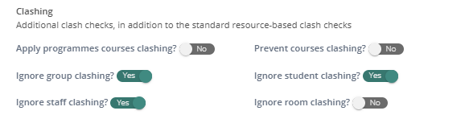
Programmes courses – will prevent an event from scheduling if two ‘mandatory’ courses on different programmes are at the same time. (NB – we don’t use this, as this doesn’t distinguish between Lectures (WHOLE CLASS) and group events (SUB GROUP))
Course – will prevent two events from the same course scheduling at the same time. (NB – we don’t use this, as this doesn’t distinguish between Lectures (WHOLE CLASS) and smaller group events (SUB GROUP))
Groups – Will allow two events with the same ‘Group’ to schedule at the same time (NB: a ‘Group’ is a piece of data usually representing a collection of students – and not in the scope of this project)
Students - Will allow two events with the same attending Student to schedule at the same time
Staff - Will allow two events with the same attending Student to schedule at the same time (NB: staff assignments are not in the scope of this project)
Rooms - Will allow two events in the same room to schedule at the same time

Allocation Strategies:
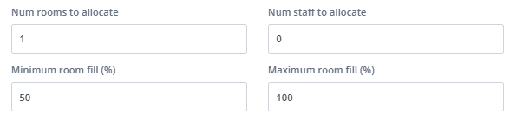
Number of rooms – the number of rooms the engine will assign to each event
Number of staff – the number of staff the engine will assign to each event (NB: staff assignments are not in the scope of this project)
Minimum/Maximum Room fill % - will allow events to book rooms if their size falls within these % thresholds of a room’s capacity

Rooming Strategies:
Best Fill – Prioritises events sizes filling a room’s capacity to the highest percentage /events will go in a room of the appropriate size
Fewest Rooms – Prioritises events using the fewest number of available rooms
Largest Rooms – Prioritises events using the largest available rooms first

Travel Constraints:
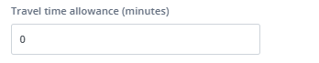
We can allow the number of minutes of travel allowed (per event > event move). We have pre-set travel times which we use for travel between campuses, and these can be used to calculate minutes of travel for staff and students.

Accessibility constraints
When Timetabling are made aware of an accessibility requirement for Staff or a Student, we deal with this in a separate and ‘primary’ scheduling batch, so that they are the first selection of events to hit their targets (NB: accessibility not in the scope of this project)

Event – room constraints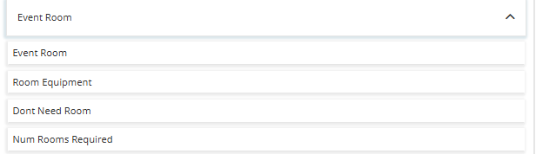

Event Room – allows you to set a hard or soft constraint so an event ‘prefers’ to be scheduled in certain rooms
Event Equipment – allows you to set a hard or soft constraint so an event ‘prefers’ to be scheduled in rooms with specific equipment
Don’t Need Room – allows you to set a hard constraint so an event does not need a room
Num Rooms Required – allows you to set a hard constraint so an event is assigned multiple rooms

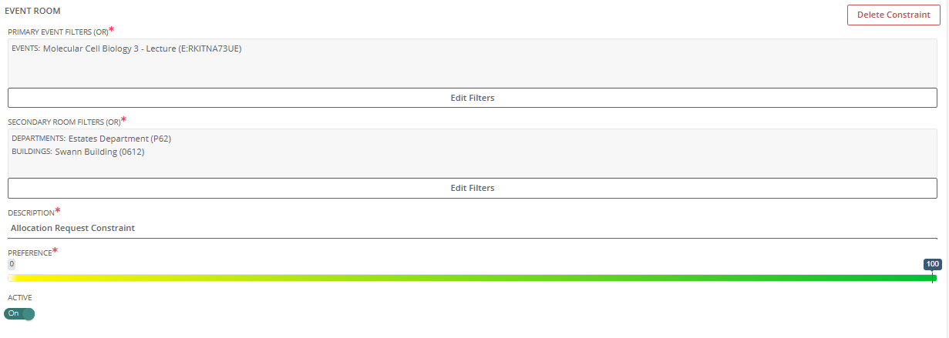
Example: Event Room – there is a 1-100 scale to determine if a constraint is ‘hard’ (100) or ‘soft’ (1 to 99)

Event – time constraints

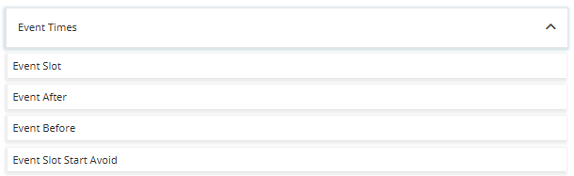

Event Slot - allows you to set a hard or soft constraint so an event ‘prefers’ or ‘avoids’ to be scheduled over certain times
Event After - allows you to set a hard or soft constraint so an event ‘prefers’ to be scheduled after another event in the week
Event Before - allows you to set a hard or soft constraint so an event ‘prefers’ to be scheduled before another event in the week
Event Slot Start Avoid - allows you to set a hard constraint so an event will not be scheduled to start at a certain time

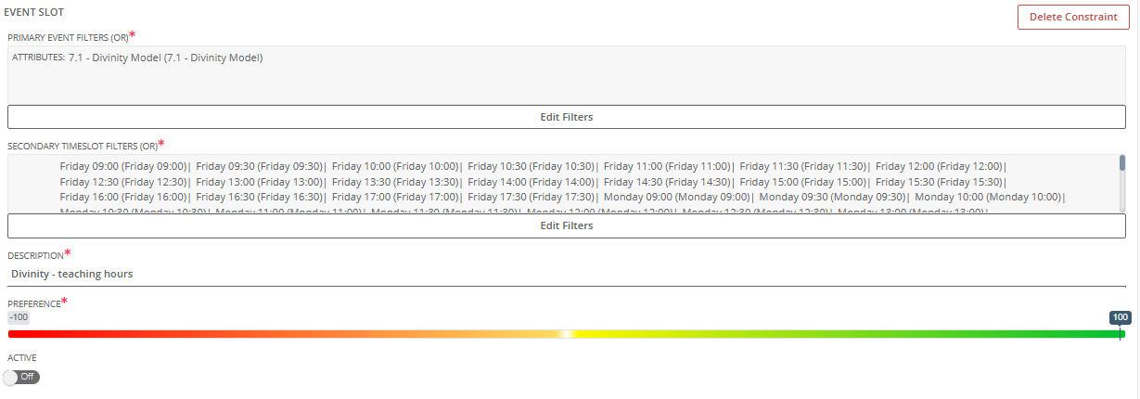

Example: Event Slot – there is a -100 to 100 scale to determine if a constraint is ‘hard avoid’ (-100) or ‘soft avoid’ (-99 to -1), ‘hard prefer’ (100) or ‘soft prefer’ (99 to 1)

